Proposal: Tech for Life – A 25th Period Program for Year 12

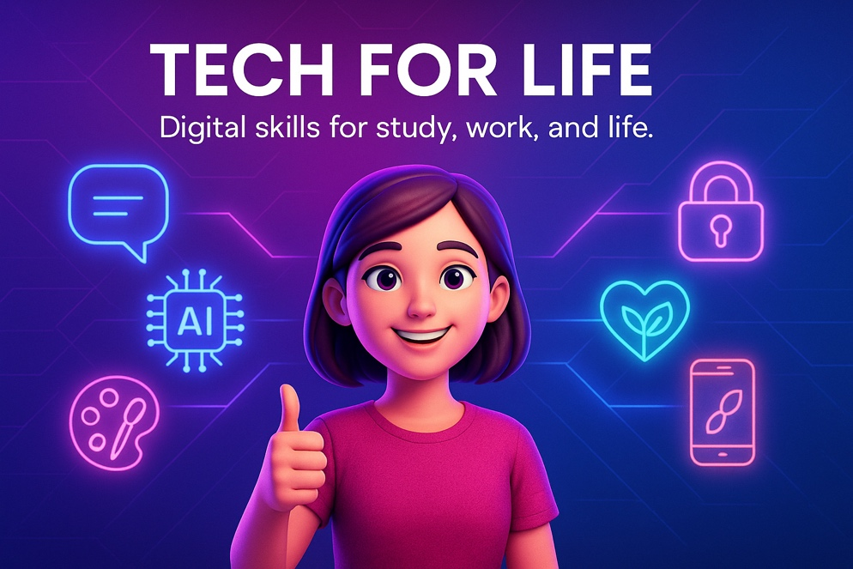

Rationale

As students approach graduation, many express uncertainties about how to manage the digital, financial, and administrative aspects of adult life. While subjects such as Careers Education prepare students for pathways and employment, there remains a clear need for a program that ties together practical technology skills with real-world life readiness.

Tech for Life is designed to equip students with the confidence and capability to navigate life beyond school from managing personal information and finances, to understanding emerging technologies, to using digital tools effectively in study, work, and daily life.

This program aligns with Denmark Senior High School’s vision for future-focused, holistic education, ensuring that every graduate leaves with the digital literacy, awareness, and independence required for modern adulthood.

Purpose

To develop students’ confidence and capability in using technology for everyday life, further study, and employment, while fostering digital responsibility, critical thinking, and practical problem-solving skills.

Students will explore how technology connects to real-world systems such as communication, finance, safety, and personal organisation.

Delivery Overview
- Duration: 3 Terms (10 weeks per term)
- Session Length: Weekly 25th Period (approx. 60 minutes)
- Focus: Hands-on demonstrations, short interactive activities, and guest speakers
- Delivery: Led by Digital Technologies staff with contributions from local professionals

Program Focus

Term 1 – Everyday Digital Confidence
- Advanced use of Word, Excel, and Google Workspace for study and personal productivity
- File organisation and cloud storage (OneDrive, Google Drive, Dropbox)
- Professional digital communication, writing effective emails, CC/BCC, tone, signatures
- Introduction to free and student-accessible digital tools (Canva, AI apps, cloud services)
- Building a digital presence (LinkedIn, digital portfolios, email professionalism)

Example Sessions:
- “Digital Organisation 101” – effective file and cloud management
- “Professional Email & Online Etiquette” – communication that gets noticed

Term 2 – AI, Cyber Safety, and Smart Tech Use
- Understanding how AI tools (ChatGPT, Canva Magic, Copilot) can support learning and productivity
- Ethical and responsible AI use, including issues of privacy, bias, and misinformation
- Cybersecurity awareness including phishing, scams, password management, and privacy controls
- Managing digital footprints and social media professionalism
- Balancing technology use and digital wellbeing

Example Sessions:
- “Spot the Scam” – recognising and avoiding digital fraud
- “AI for Everyday Life” – practical uses of generative AI tools

Term 3 – Digital Life Admin and Financial Literacy
- Understanding myGov, the ATO, tax returns, TFNs, and superannuation
- Navigating online banking, PayID, and budgeting tools (MoneySmart, Pocketbook)
- Reading payslips and understanding employment rights
- Basics of ABNs, small business setup, and online invoicing tools (Xero, Canva, Square)
- Scanning, signing, and sharing documents digitally and securely

Example Sessions:
- “Understanding Tax and myGov” – navigating essential government platforms
- “Money and Me” – digital budgeting and finance for young adults

Learning Approach

Tech for Life emphasises practical engagement and real-world relevance.
Each session introduces students to a key digital life skill or concept through short, interactive demonstrations and discussions.
Guest speakers and local professionals may be invited to share insights from university, small business, or technology fields.

Students gain awareness of the systems and tools they will encounter after school and the confidence to use them independently.

Resourcing Requirements
- Access to computer labs or student laptops
- Reliable internet connection
- Canva for Education and other free online tools
- Access to AI tools (ChatGPT, Gemini, Copilot)
- Guest speaker coordination (e.g. accountant, cyber safety expert, local entrepreneur)
- Demonstration materials prepared by staff

Expected Outcomes

By participating in Tech for Life, students will:
- Develop confidence using technology in study, work, and everyday contexts
- Understand how to protect their privacy, identity, and digital wellbeing
- Use AI and online tools productively and responsibly
- Navigate essential systems such as tax, superannuation, and online banking
- Gain awareness of business and finance basics
- Leave school with greater independence and readiness for adult life

Alignment with School Vision

Tech for Life supports Denmark Senior High School’s commitment to future-focused, student-centred learning by:
- Strengthening real-world capability and confidence
- Encouraging digital citizenship and adaptability
- Bridging school learning with the practical realities of life beyond graduation

Conclusion

Tech for Life provides Year 12 students with a meaningful, practical, and empowering transition into adult life.
By connecting digital skills, financial awareness, and real-world understanding, the program ensures our students are not only academically ready, but life ready.

Cyber security

https://www.esafekids.com.au/protective-behaviours-body-safety-course since no access we’ll create our own for year 12s.

For finance we are using https://learn.mandymoney.com.au/#/

And this course will run for 3 terms only one period a week, 25 minutes course time per lesson and the rest is a study period.

